PHP Assess Task: Product Info (for database design)

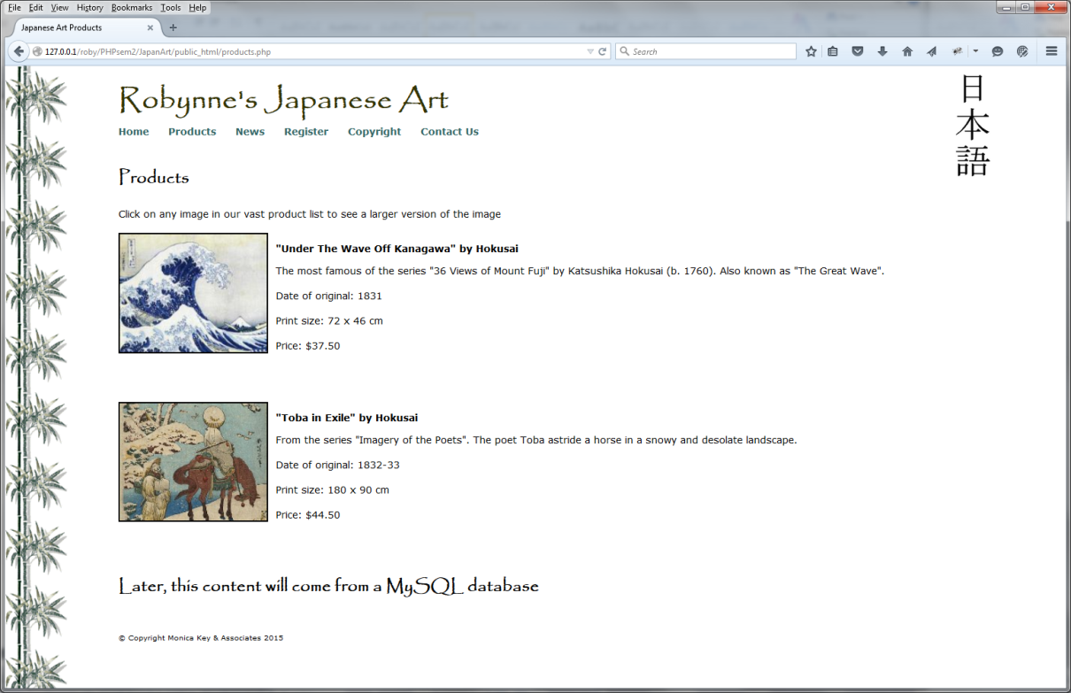

**Category * *(used in column 1 in table below)***

1. lithograph 4. calligraphy
2. screen 5. etching
3. woodblock 6. painting

|  |  |  |  |  |  |  |  |
| --- | --- | --- | --- | --- | --- | --- | --- |
| **Cat \*** | **Title** | **Artist** | **Date of original** | **Print**  **Size** | **Jpg image**  **Filename** | **Price**  **($AUD)** | **Description** |
| 3 | Samisen Player | Eisen | ca. 1830 | 44 x 65 cm | eisen01 | 35.00 | A seated bijin playing a samisen. From the series “48 Characteristic Aspects” Ukiyo-e Shijuhachi Kuse. |
| 3 | Toba in Exile | Hokusai | 1832-33 | 180 x 90 cm | hokusai01 | 44.50 | From the series “Imagery of the Poets". The poet Toba astride a horse in a snowy and desolate landscape. |
| 3 | Mountain Retreat | Nishijima | 20th C. | 170 x 130 cm | nishijima01 | 40.00 | Mountain retreat amid pines during snowfall. Nishijima’s contemporary woodblock prints are becoming very popular around the world. |
| 3 | Fujieda | Eisen | ca. 1830 | 60 x 90 cm | eisen02 | 32.75 | A standing bijin from a mitate series, on the Tokaido road. From the ukiyo-e series “53 stations of the Tokaido”. |
| 1 | Some While | Toko Shinoda | 1996 | 36 x 50 cm | shinoda01 | 25.00 | The elegant simplicity of this remarkable work hints at the influence of Shinoda’s earlier work with traditional calligraphy. |
| 3 | The Waterwheel | Hokusai | ca.1831 | 95 x 63 cm | hokusai03 | 37.50 | View of the waterwheel at Onden. From the ukiyo-e series “36 Views of Mount Fuji” |
| 6 | Woman in summer dress | Hashiguchi | early 20thC. | 80 x 140 cm | hashiguchi01 | 39.90 | This painting by Hashiguchi (1880 to 1921) reflects the quest to retain Japanese character during the westernisation of the Taisho era. |
| 4 | Calligraphy by Saga | Saga | early Heian | 24 x 50 cm | saga01 | 20.00 | Early Heian period calligraphy by Emperor Saga. (Heian period 794-1192) |
| 2 | Wild Sakura | Norinaga Motoori | late 18th C. | 100 x 25 cm | norinaga01 | 42.50 | 18th century screen depicting wild sakura in the mountains of Yoshino, south of Nara |
| 3 | Sushu Nakahara | Hokusai | ca. 1830 | 45 x 70 cm | hokusai02 | 35.00 | View of travellers on a plank bridge covering a stream in Sagami province. From the series “36 Views of Fuji” |
| 1 | Evening Calm | Toko Shinoda | 2002 | 50 x 35 cm | shinoda02 | 25.00 | An excellent reproduction of a lithograph by one of Japan’s foremost female artists. |
| 3 | Kakudayu the Robber | Natori Shunsen | ca. 1927 | 35 x 50 cm | shunsen01 | 25.00 | Dramatic portrayal of the actor Ichikawa Ennosuke as the robber Kakudayu in the play Toyama Seidan. From the series “36 Portraits of actors in various roles”. |
| 4 | Kakudayu detail | Natori Shunsen | ca. 1927 | 15 x 30 cm | shunsen02 | 12.50 | Beautifully reproduced calligraphy detail from “Kakudayu the Robber”. A print of the work from which this was taken is also available for purchase. |
| 3 | Fine Day | Nishijima | 20th C. | 30 x 23 cm | nishijima02 | 20.00 | A bold, eye-catching print of a Japanese entranceway accented by traditional roof tiles and bright covered windows. |
| 5 | Winter Vista | Tanaka Ryohei | ca. 2004 | 36 x 50 cm | ryohei01 | 27.50 | Faithful reproduction of the fine detail found in the intaglio etchings of this world-renowned artist. |
| 3 | Bijin | Kuniyasu | ca. 1830 | 45 x 70 cm | kuniyasu01 | 35.00 | A bijin seated by a screen. from the series “Suikoden Goketsu Hyahu-hachi Nin” |
| 4 | Poem of Kodai no Kimi | unknown | late 12th C. | 35 x 25 cm | kodai01 | 18.75 | The court lady Kodai no Kimi and one of her poems |

**Gallery**

